Entry Name:  **"TTU-Ketring-MC1"**

**VAST Challenge 2019  
Mini-Challenge 1**

**Team Members:**

*Jordan Ketring, Texas Tech University, Jordan.Ketring@ttu.edu*

**Tools Used:**

*R, Microsoft Excel*

**Approximately how many hours were spent working on this submission in total?**

*25*

**May we post your submission in the Visual Analytics Benchmark Repository after VAST Challenge 2019 is complete?**

**Questions**

**1** – Emergency responders will base their initial response on the earthquake shake map. Use visual analytics to determine how their response should change based on damage reports from citizens on the ground. How would you prioritize neighborhoods for response? Which parts of the city are hardest hit? Limit your response to 1000 words and 10 images.

***The focus of the emergency responders, if following the earthquake shake map, started on locations 3, 4, and 12. Following that, they would have focused on locations 7, 13, and 14 and other neighboring locations. Following are the mean values of the citizen damage reports divided up by location.***

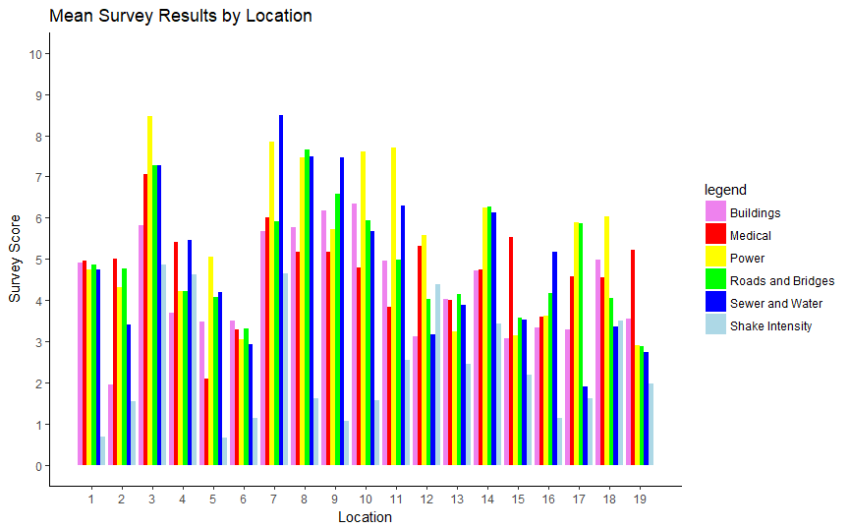

***The data provided by citizen damage reports included six different evaluations of damage. Deciding where to focus emergency responders depends on the relative priority of these different types of damage. Therefore, we will evaluate each type of damage individually.***

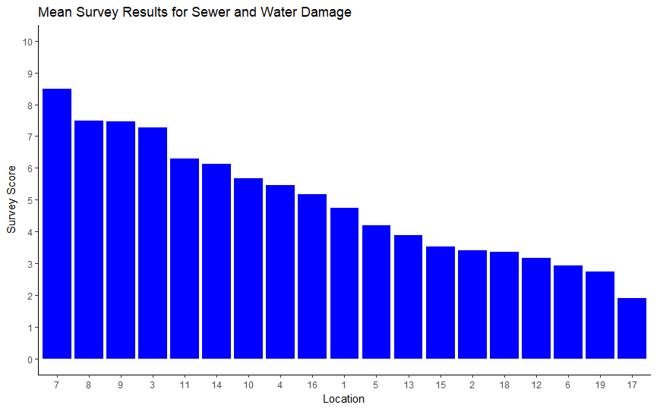

***Sewer and water damage affected locations 7, 8, 9, and 3 to a greater degree than other locations, according to damage reports. A paired t-test proves this for locations 8, 9, and 3 with p-values all <0.001. However, location 7, due to a smaller sample size of data, is not certain to be of greater damage than locations 11, 14, or 10.***

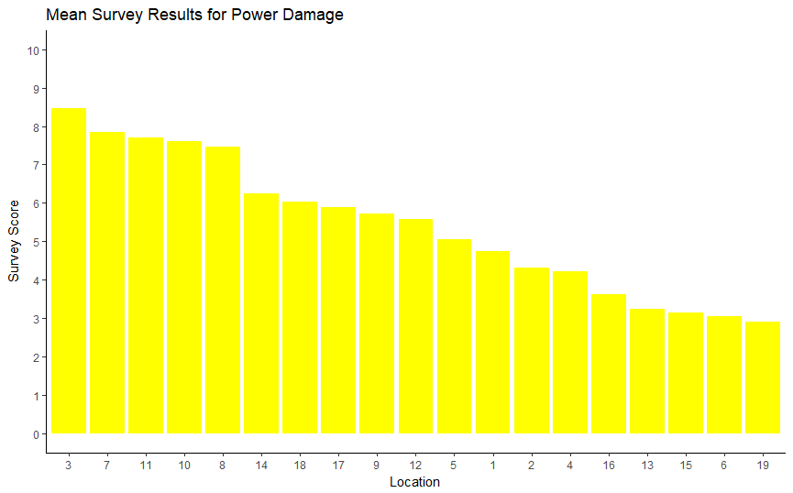

***Damage to the power infrastructure falls most heavily on locations 3, 7, 11, 10, and 8. This group of locations has higher mean damage according to a paired t-test with all p-values <0.001.***

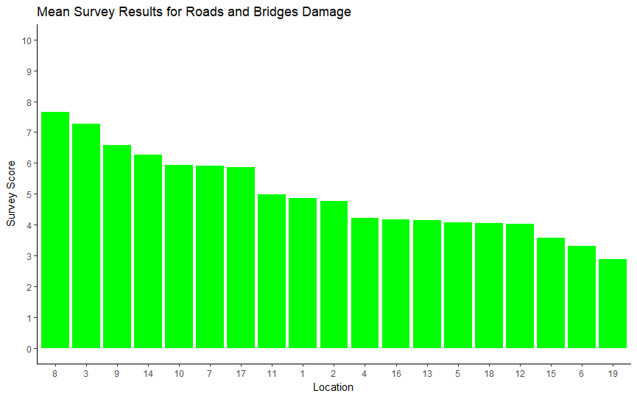

***Damage to roads and bridges falls most severely on locations 8 and 3. A paired t-test shows they have a higher mean damage than all other areas with all p-values <0.001.***

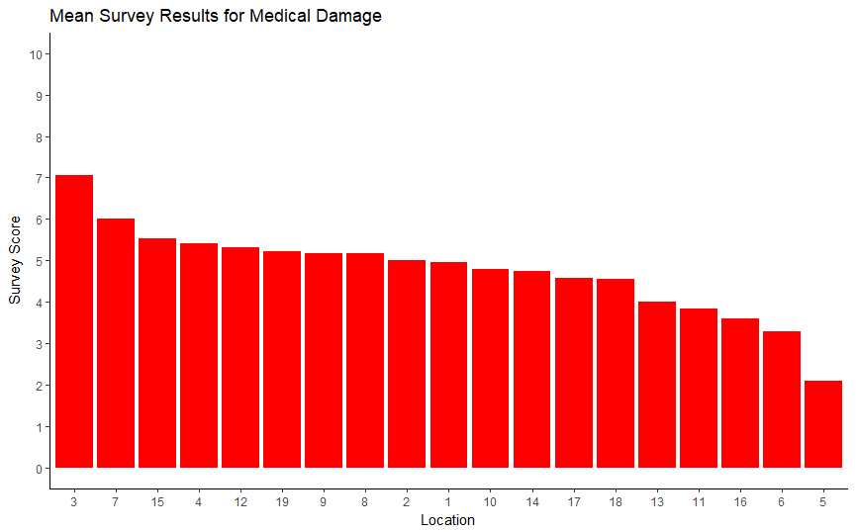

***The location that suffered the most damage to medical facilities was location 3. Due to a lack of response in many locations to this survey question, presumably because of a lack of hospitals in some areas, paired t-tests were not possible. However, location 3 is the only front runner in damage that contains a hospital at all.***

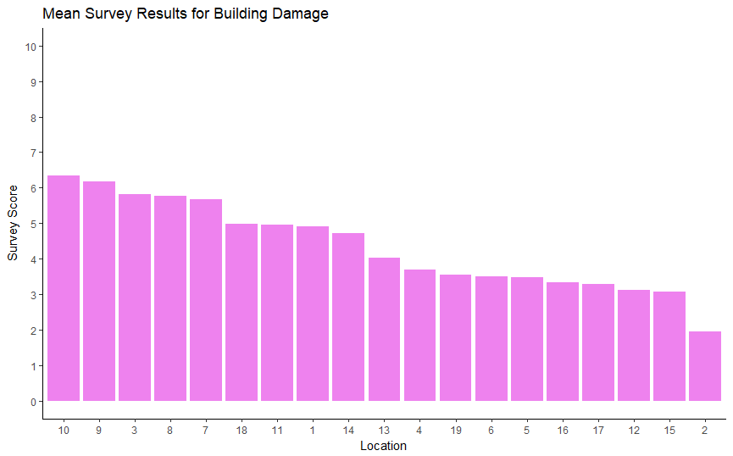

***The locations with the highest reported building damage are 10, 9, 3, 8, and 7. Again location 7 has one of the highest reported mean damage scores, but due to a smaller sample size, a paired t-test is unable to separate it from the rest of the locations. Locations 10, 9, 3, and 8 however, all have greater damage reports than the remaining locations with p-values <0.001.***

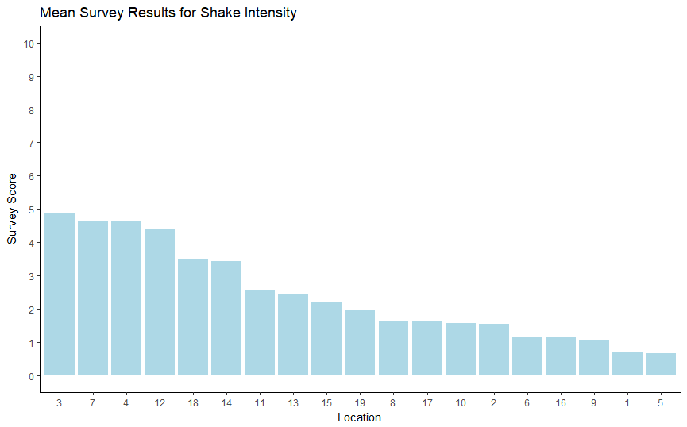

***Shak intensity is not a direct measure of damage or suffering, and therefore is not likely a good metric to base the focus of relief efforts on. However, it validates the user reported data, as all locations’ mean reported shake intensity agrees strongly with the shake map.***

***To evaluate which locations deserve the most focus we may examine which locations consistently reported the most damage in each category.***

|  |  |  |  |  |  |  |
| --- | --- | --- | --- | --- | --- | --- |
| **Damage Type** | **3** | **7** | **8** | **9** | **10** | **11** |
| Sewer and Water | * | * | * | * |  |  |
| Power | * | * | * |  | * | * |
| Roads and Bridges | * | * | * |  | * | * |
| Medical | * |  |  |  |  |  |
| Buildings | * | * | * | * | * |  |
| Sum | 5 | 4 | 4 | 2 | 3 | 2 |

***Of these, location 3 is the only one to appear at the top of every damage report. Regardless of which type of damage is prioritized, location 3 should be among the first locations where aid is focused. As this location was already covered by the shake maps, it was likely already a focus of attention. Locations 4 and 12 however, do not need as much focus according to damage reports, and attention can be diverted from them to locations 7 and 8. Attention given to locations 9, 10, and 11 would depend upon the importance of repairing sewer and water damage compared to that of restoring power and repairing roads and bridges, thus a value judgement is required that is beyond the scope of this analysis.***

**2** – Use visual analytics to show uncertainty in the data. Compare the reliability of neighborhood reports. Which neighborhoods are providing reliable reports? Provide a rationale for your response. Limit your response to 1000 words and 10 images.

***The reliability of the survey data can be evaluated in two different ways. Each location provided varying amounts of sample data. The number of responses can be used to calculate the statistical power of each locations’ data set. In other words, statistical power tells us the likelihood we can detect differences between each group of a certain size. The other method is a comparison of the variances within each locations’ responses. This is our best indication of the consistency with which observers in the same area provided the same ratings for each type of damage.***

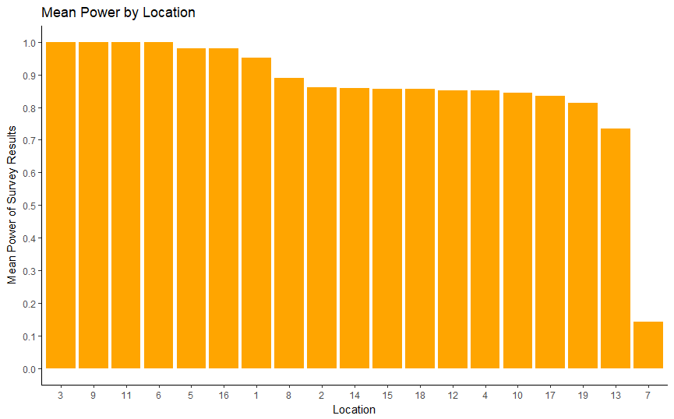

***The power of each location’s data set to detect a difference of 0.1 in score with a p-value < 0.05 is depicted above. The data set of every location has enough statistical power to calculate even small effect sizes, except for location 7. This is consistent with the findings that multiple p-values in paired t-tests between location 7 and other locations were above the threshold for significance.***

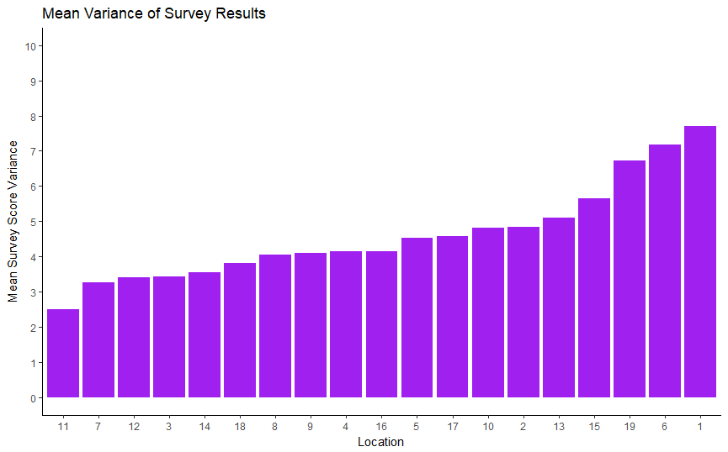

***The mean variance of each variable, divided by location is depicted above. The locations with the lowest variance have the greatest consistency, and therefore the best reliability.***

***Locations 11, 12, 3, and 14 provided the most reliable data as evidenced by their low variances. Location 7 is an exception, because although it has a low variance, its data does not have the statistical power to be considered as trustworthy as the other locations’ data.***

**3** – How do conditions change over time? How does uncertainty in change over time? Describe the key changes you see. Limit your response to 500 words and 8 images.

***After one day from the first data submission, areas show much lower ratings of damage then later data reports. For sewers and water as well as building damage, an analysis of variance test does not indicate significant differences between any locations.***

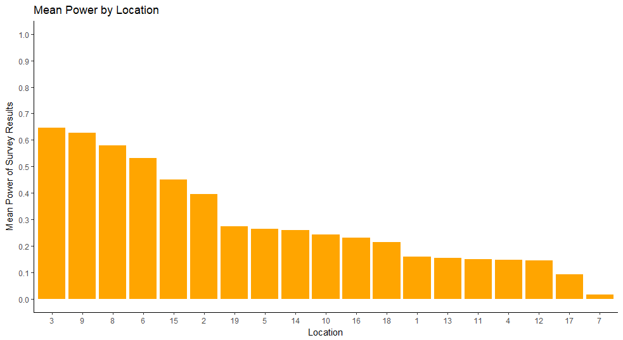

***No locations have enough power to detect differences of 0.1 with significance, using a typical minimum power of 0.8.***

***None of the types of damage have particular locations with higher mean reports than all others with significance indicated by a p-value < 0.05. This means that after a single day of gathering data, no certain statements could be made as to the appropriate priorities to focus on, and a shake map would serve just as well as a guide to emergency responders.***

***After two days from the first data submission, the analysis of variance test yielded the same results as with a single day of data. No significant differences were found in the sewer and water and building damage types. No location had proved to be more damaged than most others through a paired t-test for power and medical damage, but location 13 showed significantly more damage than every other location in damage to roads and bridges.***

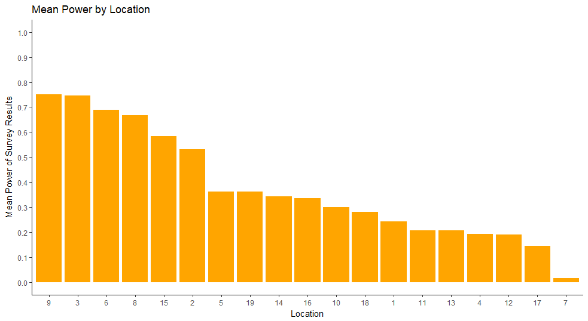

***Only locations 9 and 3 show enough power to detect differences of 0.1 at a p-value of <0.05.***

***After three days of gathering data, every category shows that there are significant differences between groups from an analysis of variance.***

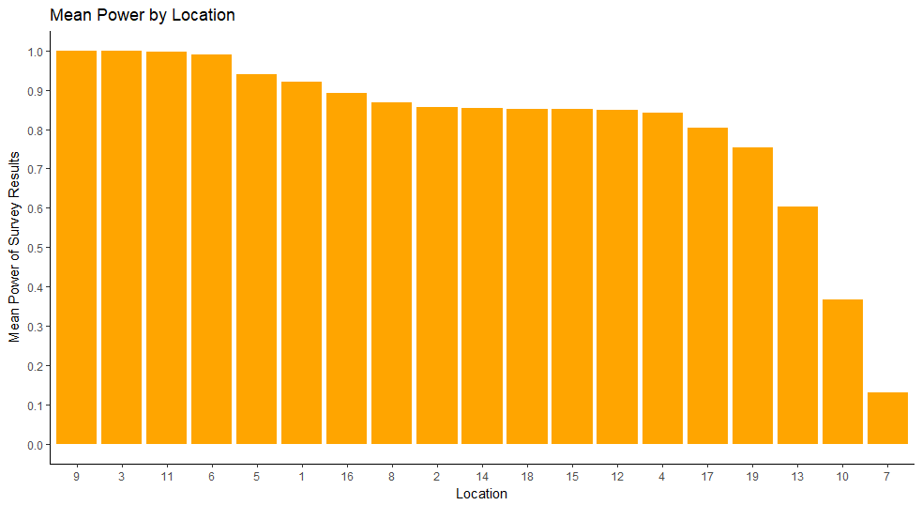

***The power to detect differences of 0.1 with a p-value <0.05 is acceptable for most of the locations, except 13, 10, and 7.***

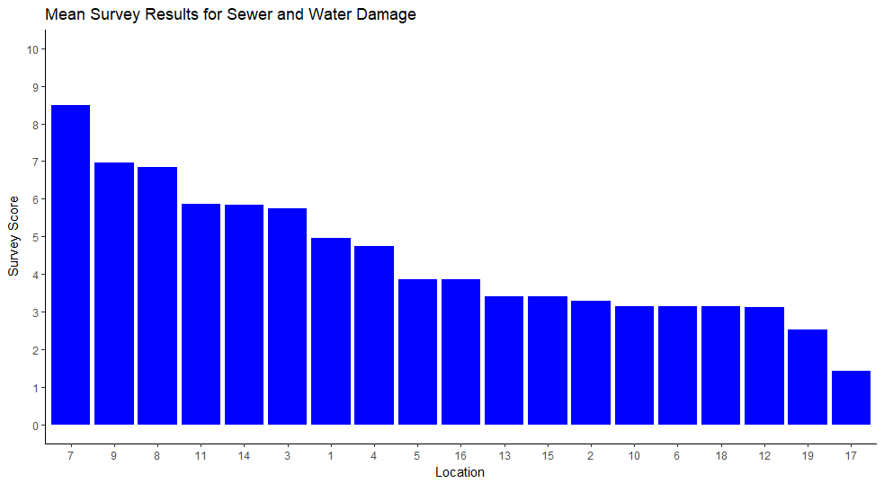

***The sewer and water damage shows similar results to the final data set, this time with significant p-values <0.05 from a paired t-test for locations 7, 9, 8, 11, 14, and 3.***

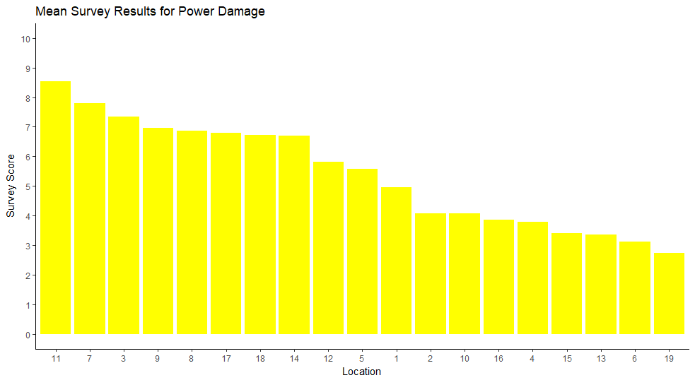

***Likewise power damage shows significantly higher results in locations 11, 7, 3, 9, and 8. This closely mirrors the final findings.***

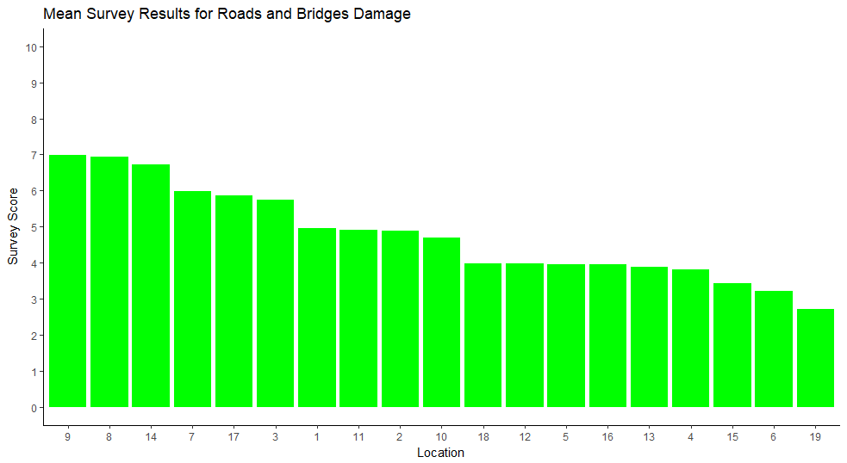

***The mean damage reported for roads and bridges has results that are significantly higher than all other locations for 9, 8, 14, and 7. This somewhat resembles the final analysis that included 8 and 3 as the top locations.***

***The medical data again is too sparse for a successful paired t-test, but location 3, clearly shows the most damage, just like the analysis with all data present.***

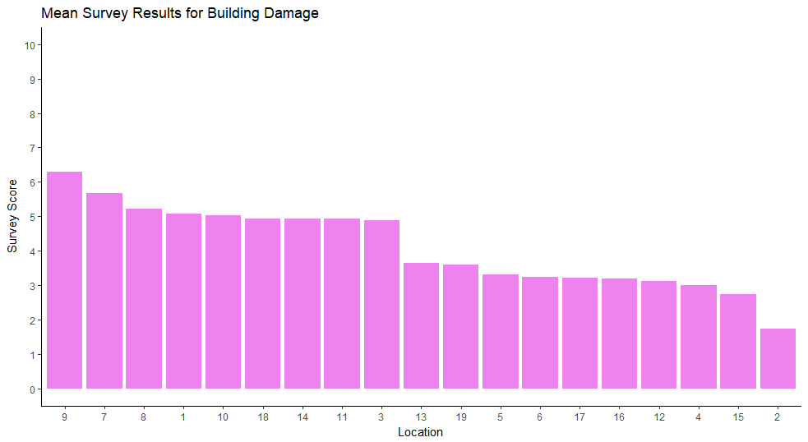

***Locations 9, 7, and 8 show mostly significantly larger means when compared to other locations via t-test. This fits closely to final results.***

***Until 3 of the 4 days of observation have passed, the data is too uncertain to provide meaningful insight on which locations deserve the highest priority. After 3 days, the results showed very similar findings to the analysis of the final data set, with a recommendation to prioritize locations 3, 7, 8, and 9.***

**4** –– The data for this challenge can be analyzed either as a static collection or as a dynamic stream of data, as it would occur in a real emergency. Describe how you analyzed the data - as a static collection or a stream. How do you think this choice affected your analysis? Limit your response to 200 words and 3 images.

***The data was analyzed as a static collection. Had it been analyzed as a dynamic stream, no conclusive recommendations would have been possible until 3 days’ worth of data had come in. The choice of which locations to focus emergency aid on did not significantly differ over time once there was enough data for significant results.***